**Geolocating Images**

TryHackMe room to understand how to geolocate images

This tutorial will show you how to geolocate images.

To do this, we use a reverse image searching program.

Yandex is the most popular reverse search program.

You could also use Bing.

I’ve heard that Google reverse image should be your last resort.

When you reverse image search with Google, Google tries to find the exact match of that image. With Yandex, it's almost as if Yandex knows what your image is of straight away and shows you other images of the same thing to reinforce the idea that it knows.

Yandex uses AI to reverse image search, whereas it feels like Google is doing a simple "if IMG_0657 = [Position 1 of image database]: return" against all the images it has.

For more on Yandex vs Bing vs Google, check out Bellingcat's analysis:

<https://www.bellingcat.com/resources/how-tos/2019/12/26/guide-to-using-reverse-image-search-for-investigations/>

**I was able to get my feet wet using Yandex. I just did a drag and drop with a picture.**

Where is image 1?

(Use Google Reverse Search and revel in all the airplanes it shows you, which by the way, isn't the right answer).

Try Yandex Reverse Image search. Look at the differences!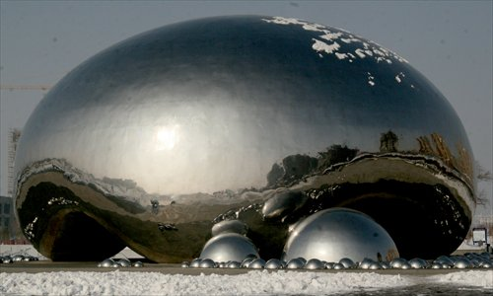

This was pretty simple!

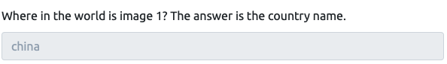

**Geolocating Images 101**

Okay, now we know what reverse image searching program to use. Let's try to look at the picture now to figure out where it is!

Let's say we have a webcam we found on [Shodan.io](http://shodan.io):

<https://padcam.liverpool.ac.uk/cgi-bin/guestimage.html>

Where is this camera?

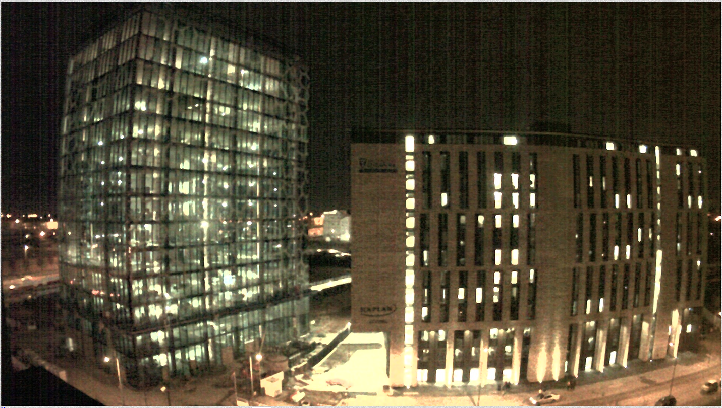

Ok, this is my first stab at something like this! Let’s just go for it!

I will list a couple of steps to help dissect this picture.

Alright, let’s figure out where in the world is this camera?

Proceeds to stare at the picture and see what’s all in the picture.

**Ah ha Landmarks..Perfect!**

Look at the buildings and the names on the building if any.

Putting this into a reverse image search program shows nothing.

Next, lets work with the information that was given to us!

**Ding Ding Ding**….The name of the Webcam

The URL points to [Liverpool.ac.uk](http://Liverpool.ac.uk), which is a university in Liverpool

If we just had an IP address, we could try to geolocate it using an online tool, checking the ASN number or finding it on Shodan.

Googling "Kaplan University of Liverpool" leads us to a news article about a new building. If we look at the image, it looks approximately similar to the one we saw.

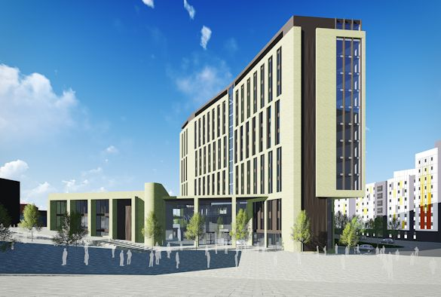

Rows of long glasses with a little bit of overhang.

Luckily, Liverpool have captioned the image.

"The proposed new Liverpool International College facility"

If we google Liverpool International College we get:

<https://www.google.com/maps/place/University+of+Liverpool+International+College/@53.4062447,-2.9625347,17z/data=!4m5!3m4!1s0x487b211eda1b2f5f:0xc226c2ccfb209504!8m2!3d53.4060784!4d-2.9605928>

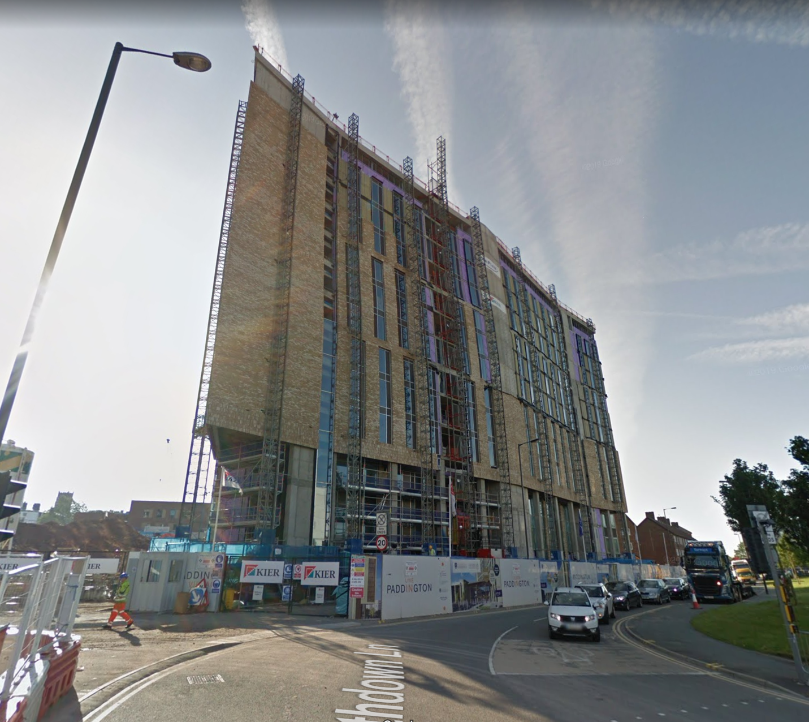

In this picture it’s the building right but it’s not finished soo yea lol and at the bottom right hand corner, Google tells us the image was captured in June 2019. Use maps to kind of look all around the area.

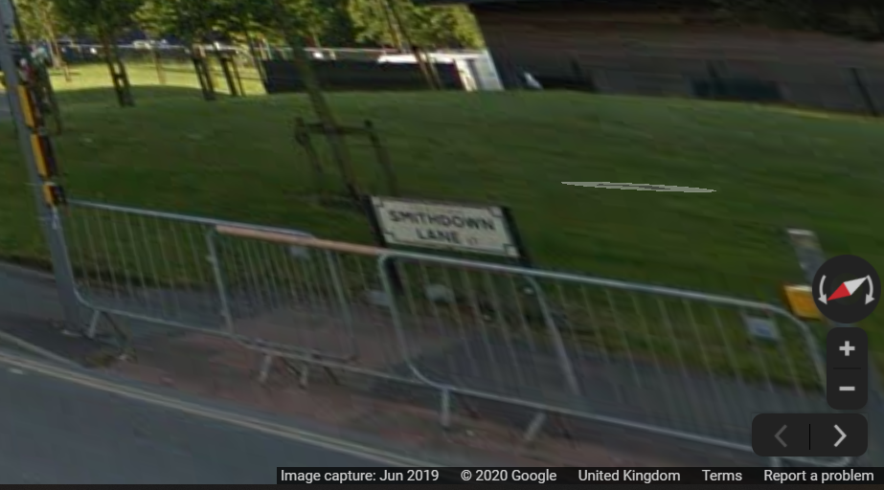

So Google maps hasn’t updated yet.

If we turn the camera around on Google maps, we can see where the live webcam should be.

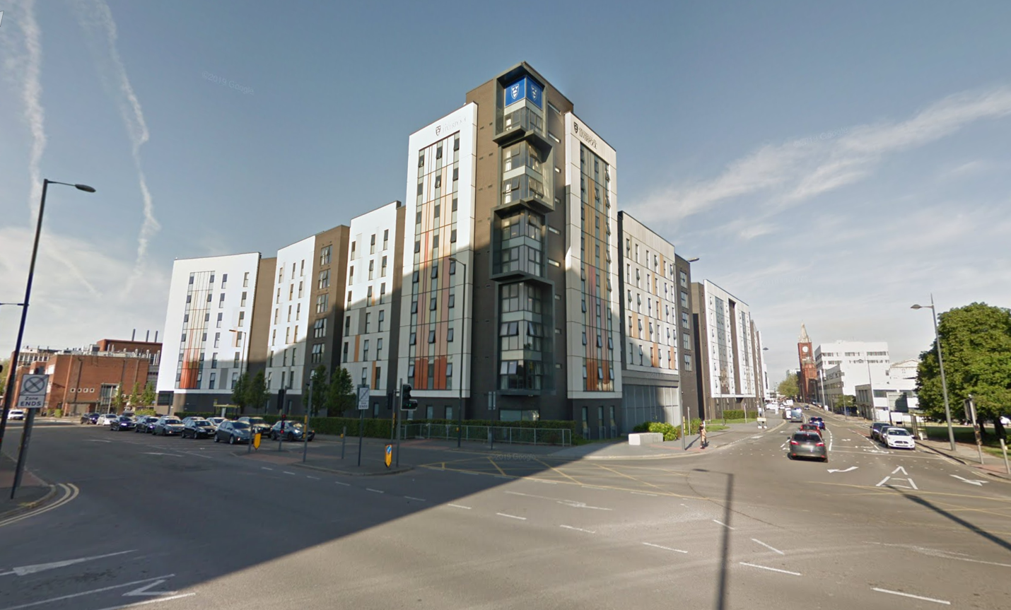

Somewhere on this building!

When geolocating an image, we want to point out big landmarks we can easily find on a map. Road layouts, business names, The Empire States Building.

Now it’s my turn to try to do this on my own! Well, here we go! I’m looking to see if I can find the name of the place where the webcam is setup. I did not use the reverse search lookup.

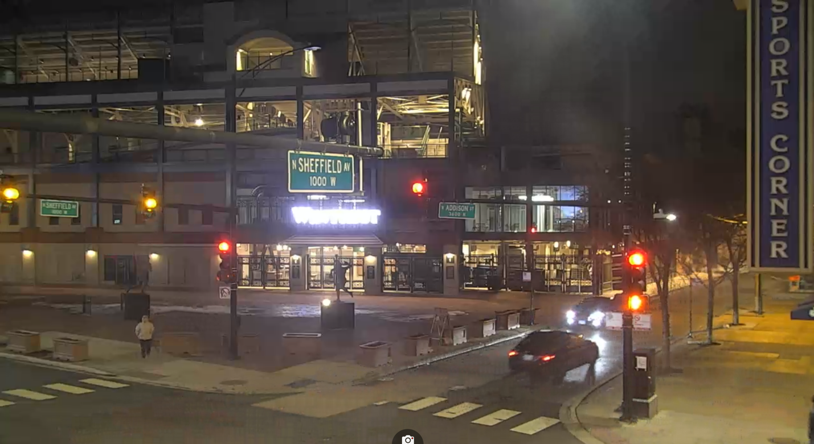

Ok so for starters I can tell the webcam is across from a stadium. I see the name of the streets. I also see that there is possibly a building called **Sports Corner**.

In google I type in the street names along with Sports Corner. I was able to find out this is a picture of Wrigley Field in Chicago, IL. I use google maps to zoom in and out to see what’s around this stadium. I was then able to use the street view and see what building is across the street from sports corner.

**The answer is Wrigleyville sports.**

**Helpful tips for geolocating**

It's important to know what is and isn't likely to be in a country.

The language used on the shops and vehicles matter too. We can use Google translate to predict what language it could be.

Which side of the road the cars are on, the license plates (you normally can find out what country or state the license plate is from), the markings on the road (different countries have different markings), the style of traffic lights, the clothing choices of those walking around.

To be good at geolocation, we've got to open our eyes to all that could be. In your country, for example, it may be common to wear coats during the winter periods. However, in other countries it may not be (think Australia).

Even the smallest of things that we wouldn't normally think twice about can reveal to us the possible location.

One of the more obvious ways we can geolocate an image is to look at the image details. Does it contain EXIF data?

What about where it was posted - is there a location tagged on social media?

Ok so it’s my turn again!

I promise I didn’t use the reverse image search. Attention to details comes in to play here. I’m looking for the name of the place the webcam is facing.

REALLY! OMG!

**Note:** the name of this location on Google Maps is not the right answer. If you take that location name and paste it back into search, you'll find out there's about a million of them. To make this harder, I'm looking for the name that specifically identifies this location. When you enter this name, it'll be the only one that turns up on Google Maps.

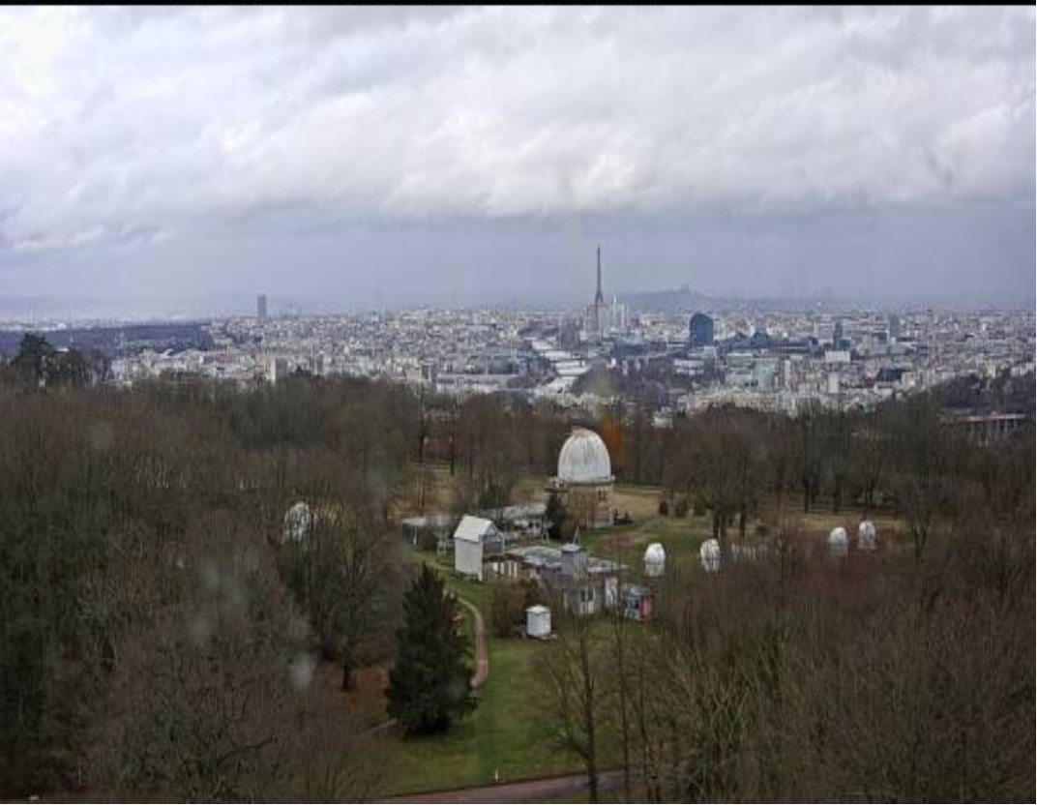

**Ok here is a hint!**

Is that the Eiffel Tower? And what's that white building?

So PARIS hmmm ok thanks for the hint!

I really have no clue where to even start with this one.

Maybe I start with the obvious. Google search of webcams showing the Eiffel tower. Proceeds to go through a ton of websites looking at the webcam positions. Ugh can’t find any showing the Eiffel Tower in the far far distance compared to the picture.

Okay let me regroup and go back to the HINT.

I have no clue what the white building is. Let’s see if I can find out.

Ok no luck. Bare with me.

Ok let me go back to my idea with the webcams. Maybe I should work on my researching skills here and be more specific. I should just find a webcam site and search Paris, Eiffel Tower…SOMETHING!

I can do a search for worldwide webcams in Paris. Maybe I can locate this specific picture.

Found this site

<https://www.webcamtaxi.com/en/>

and did a search on the keyword Paris

FOUND THE PICTURE! The EXACT PICTURE!! WOW!!

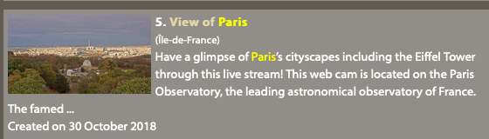

From here I see that this webcam is located on the Paris Observatory. I place this location in google search so I can find the exact location.

**Answer**: Meudon Observatory

**I get to try another one!**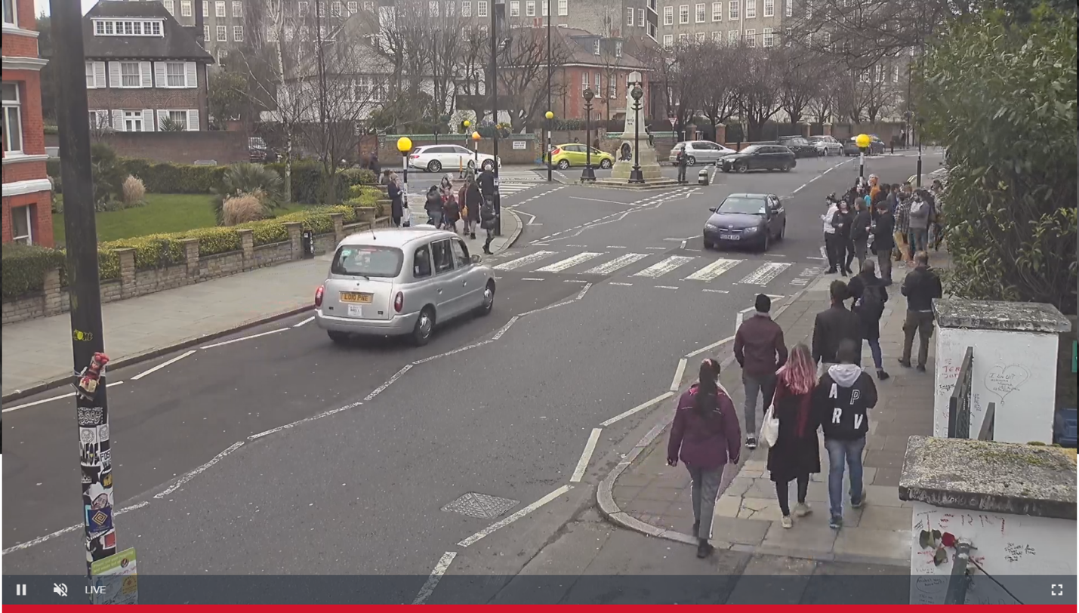

What do you see? What can you observe?

Let’s see.

For starters, I see stickers on the pole and stuff written on the wall.

I can tell that this picture was taking from a webcam because the cars are moving.

It has a crossing specifically in this picture a zebra crossing

I can see the tag number on the grey car.

Tag number is Lo10 PNE.

With this information I can go to Google and see if I can get a city location from it.

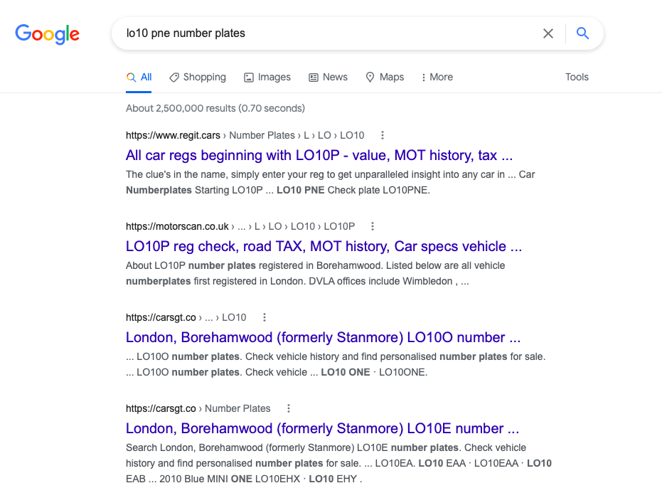

So now we know that the location is London

Now I can search zebra crossing in London maybe I can find a similar picture or even the exact same place.

By looking at the images and comparing to the details in the picture. I decide to click on a link and see if I can find the location of this most famous road. I was able to find Abbey Road.

I did a couple searches on Abbey Road and YES! it’s definitely Abbey Road.

I must say I had to put my thinking cap on and dig deep into my googling skills. Observation was key here. Having a close eye on the details helped me out big time.

And that's it!

Check out Bellingcat for more on geolocation:

<https://www.bellingcat.com/news/2020/01/21/geolocating-venezuelan-lawmakers-in-europe>

Alternatively, play a lot of Geoguesser!

<https://geoguessr.com/>